Dragon Naturally Speaking 7.0, 8.0, 9.0, 10.0 Tutorial

I have created a tutorial for Dragon Naturally Speaking 7.0 which covers not only the basics of good accuracy but also creating Scripts or Macros. These can be used in other programs such as your Medical Billing / Practice Management, EMR (Electronic Medical Records) and Microsoft Word software applications
You can also view the different pages on the Website :
This document has two main sections:
1) BASICS - How to check sound quality and improve accuracy levels.
2) SCRIPTING for Dragon Naturally Speaking - Create scripts to be used within any Windows Application. For Example, create templates for examinations.
HINT: Many (hundreds) scripts are already built into Dragon. To view the most popular scripts for an individual program, just say "Open Command List" while in the specific program (obviously have DNS open also).

BASICS
1) Make sure that your microphone, headset or handheld is set up correctly. This is the number one cause of poor transcription accuracy.
Sound Test Option 1
- To test, Open your Windows Sound Recorder and record something. If it comes out warped, then that is your problem. For handhelds and digital recorders, use the sound recorder to test your sound files (.WAV files).
- To open, click "Start", "Programs", "Accessories", "Entertainment", "Sound Recorder".
- You can record something here or open a sound file that was transferred from your handheld.
Check your "Settings"
- To see settings, click "Start", "Programs", "Accessories", "Entertainment", "Volume Control". Look at both "recording" and "Playback" properties.
- Click "Options" in "Volume Control" to toggle back and forth. These options are occasionally set wrong because of some other program. Adjust them until you get a good recording.
- Note "SPDIF" should be muted in XP.
Sound Test Option 2
- Within Dragon, Open "Accuracy Center" (Click "Tools", "Accuracy Center").
- Click "Check your audio settings". Run this test.
2) Another major cause of poor transcription accuracy is not having your profile matched with your current headset, microphone or handheld.
- Each recording device (headset, etc.) needs to be trained separately. A separate profile needs to be set up for each.
- You cannot just swap recording devices and continue.
3) To increase performance of transcription, run these tools from "Accuracy Center"
- Perform "Additional Training"
- Run "Acoustic Optimizer"
- Run "Increase accuracy from email"
4) Get the latest software patch from ScanSoft. http://support.scansoft.com/downloads/
5) Many (hundreds) scripts are already built into Dragon. To view the most popular scripts for an individual program, just say "Open Command List" while in the specific program (obviously have DNS open also).

SCRIPTING
Creating Scripts and Macros is very useful to truly get the most out of Dragon Naturally Speaking. Dragon software can not only be used for direct transcription but also can be used to run any Windows Application such as MS Word, a Medical Billing program or an EMR software package.
Scripts can be used to set up templates (I.E. Initial Exam) or to easily run or move around a program (I.E. Go to Next Field in a Template).
Many (hundreds) scripts are already built into Dragon. To view the most popular scripts for an individual program, just say "Open Command List" while in the specific program (obviously have DNS open also).

GO TO NEXT PAGE

Script Creation and Management
1) To Create or Manage Scripts, open the "Command Browser". Within Dragon, click "Tools", "Command Browser". On version 10, “Mode” is on left. Click on “Task Pane” to make it look like this.
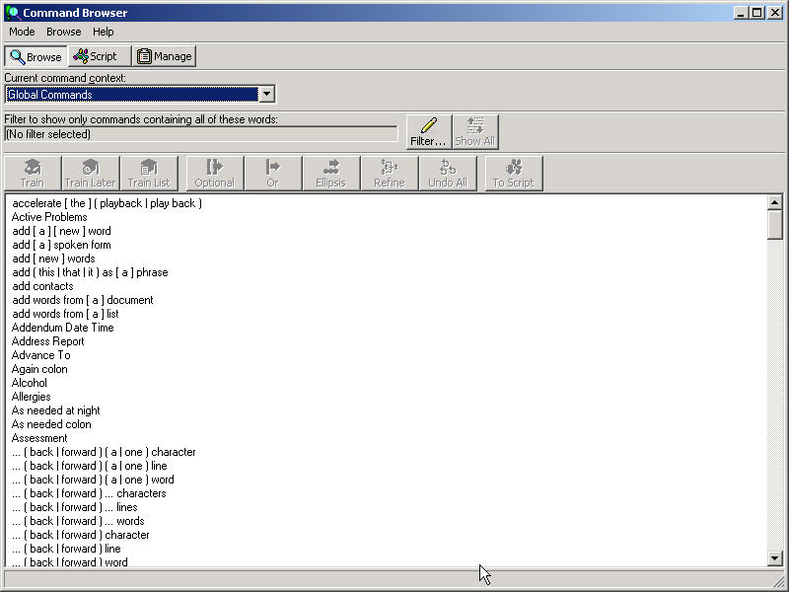
The easiest three methods of creating a script are:
- Text and Graphics
- Step by Step
- Macro Recording
GO TO NEXT PAGE

2) Text and Graphics - Best to create a template, add standard paragraphs or input a scanned signature. I give an example of a signature in graphic below.
- Within "Command Browser", click on "Script", "New".
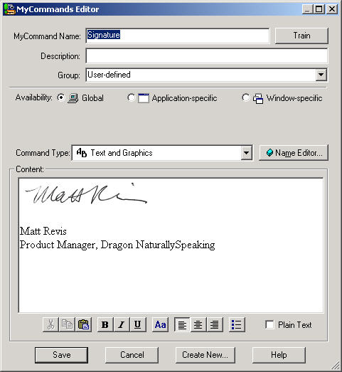
- In "MyCommand Name" type name of command.
- Click "Train" and train it to your voice.
- In "Availability", choose:
  - "Global" to have it work in all programs.
  - "Application Specific" to choose a single program for it to work in. You will also have to choose that program (which must be running at that time).
  - "Window Specific" to choose a specific Widow within a specific program (Window must be open in program).

- In "Command Type", choose "Text and Graphics"
- In "Content", type in text and/ or insert graphic (I.E. signature).
- REMEMBER TO CLICK “Plain Text” in lower right if you are using MS Word. This keeps font that is in MS Word. This has no formatting (bold, centering, etc.) If you have formatting, select text and choose font with “Aa” button (same as default font in MS Word. MS Word changes font if you change the font.
- Click "Save".
3) Step-by-Step: Best for inner program movement such as going to "Next Field" within a template. Also good for combinations of text and keystrokes. I use the example of "NextField" in the graphic below.
- Within "Command Browser", click on "Script", "New".
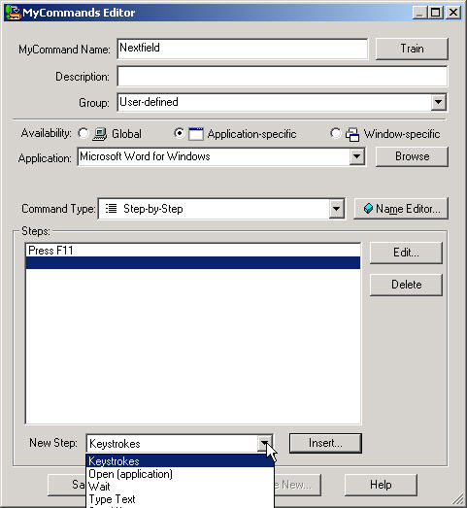
- In "MyCommand Name" type name of command.
- Click "Train" and train it to your voice.
- In "Availability", choose:
  - "Global" to have it work in all programs.
  - "Application Specific" to choose a single program for it to work in. You will also have to choose that program (which must be running at that time).
  - "Window Specific" to choose a specific Widow within a specific program (Window must be open in program).

- In "Command Type", choose "Step-by-Step"
- Click drop down arrow to right of "New Step" below "Steps" box. Choose step type.
- Click "Insert" below "Steps" box to insert a key stroke, text, etc.
- Type step (such as F11 - actually press F11 key)
- Click "OK".
- Click "Save".

GO TO NEXT PAGE

4) Macro Recording - This actually your movements on the computer including mouse, text and keystrokes. Use as a last resort due to the fact that it is slow. Good for tracking actually movements such as making a drawing.
- Within "Command Browser", click on "Script", "New".
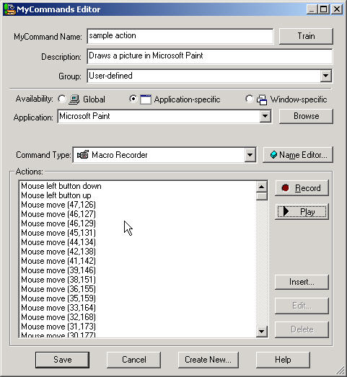
- In "MyCommand Name" type name of command.
- Click "Train" and train it to your voice.
- In "Availability", choose:
  - "Global" to have it work in all programs.
  - "Application Specific" to choose a single program for it to work in. You will also have to choose that program (which must be running at that time).
  - "Window Specific" to choose a specific Widow within a specific program (Window must be open in program).

- In "Command Type", choose "Macro Recorder"
- Click "Record".
- Command browser will disappear. A mini "Stop/Play" button wll pop up in lower left of screen. Click this to stop recording.
- Go through steps hat you want to record.
- Click stop button in mini recorder.
- Click "x" in top right of mini recorder. This will send you back to "Command Browser".
- Click "Save".

